

**VIETNAM NATIONAL UNIVERSITY  
 HO CHI MINH CITY INTERNATIONAL UNIVERSITY**

**Fitness Tracking and Training System**

**Group 3**

**Instructor:** Nguyen Thi Thuy Loan

**Group Members:**

|  |  |  |
| --- | --- | --- |
| **Stt** | **Họ và tên** | **Student ID** |
| **1** | Hồ Tiến Đạt | ITCSIU21047 |
| **2** | Nguyễn Minh Đức | ITITIU21045 |
| **3** | Phạm Quang Vinh | ITITIU21347 |
| **4** | Đỗ Đức Huy | ITITIU21217 |
| **5** | Bùi Đức Mạnh | ITITIU21076 |
| **6** | Lê Minh Phượng | ITITIU20281 |
| **7** | Nguyễn Huy Hùng | ITCSIU21064 |
| **8** | Nguyễn Toàn Phúc | ITITIU21093 |
| **9** | Vũ Đức Thiên Hoàng | ITITWE20028 |

**Contribution:**

|  |  |  |
| --- | --- | --- |
|  | **Contribution** | **Contribution Percentage** |
| Hồ Tiến Đạt | Gather requirements from stakeholders, draw BPMN | **11.1%** |
| Nguyễn Minh Đức | Prioritize and analyze requirements from stakeholders | **11.1%** |
| Phạm Quang Vinh | Create, develop and test the application | **11.1%** |
| Đỗ Đức Huy | Analyze the risks, draw Sequence diagram | **11.1%** |
| Bùi Đức Mạnh | Create, develop and test the application | **11.1%** |
| Lê Minh Phượng | Create, develop and test the application | **11.1%** |
| Nguyễn Huy Hùng | Write Use Case specification and Class diagram, Presentation | **11.1%** |
| Nguyễn Toàn Phúc | Draw Activity and Use Case diagram, Presentation | **11.1%** |
| Vũ Đức Thiên Hoàng | Create, develop and test the application | **11.1%** |

**Table of content**

**I. Introduction.............................................................................................................. 4**

**II. Key stakeholders and customer requirements…………………………………. 6**

**III. Functional requirements……............................................................................... 6**

1. **BPMN…............................................................................................................. 6**
2. **Usecase............................................................................................................... 6**

**IV.Wireframe………….............................................................................................. 12**

**V. ERD......................................................................................................................... 14**

**VI. Activity diagram.................................................................................................. 14**

**VII. Class diagram.................................................................................................... 15**

**VIII. Sequence Diagram…………………………………………………………… 16**

**IX. Requirement Analysis…………………………………………………………. 19**

**X. Risk analysis…………………………………………………………………….. 23**

**XI. Progress and challenges……………………………………………………….. 25**

1. **Timeline……………………………………………………………………... 25**
2. **Gantt chart………………………………………………………………….. 27**
3. **Milestone achieved………………….………………………………………. 28**
4. **Challenges and obstacles…………………………………………………… 29**
5. **Solutions…………………………………………………………………...… 29**

**XII. Feedback and Future improvement…………………………………………. 29**

1. **Feedback…………………………………………………………………….. 30**
2. **Future improvement………………………………………………………... 30**

**XII. References and Source Code…………………………………………………. 31**

1. **Introduction**
2. **Overview:**In this proposal, we will cover various aspects that are crucial to the success of our project. We will start by identifying the key stakeholders who will be involved in the development and usage of the app. Next, we will dive into the customer requirements, ensuring that we understand the needs and expectations of our target audience. Additionally, we will outline the functional requirements that the app should fulfill to provide a seamless customer experience. To visualize the app's structure, we will provide wireframes, an ERD, an activity diagram, and a class diagram. Furthermore, we will conduct a thorough requirement analysis to ensure that all necessary features and functionalities are included. Lastly, we will perform a risk analysis to identify potential challenges and develop strategies to mitigate them.
3. **Scope:**Fitness Tracking App with Personalized Workouts, Diets, and Daily Reminders
   * + **Workout tracking:** Track workouts by type, duration, and intensity.
     + **Nutrition tracking:** Track food and drink intake to track calories, macronutrients, and micronutrients.
     + **Fitness goal setting:** Set and track fitness goals, such as weight loss, muscle gain, or improved cardiovascular health.
     + **Personalized workouts:** Generate personalized workouts based on the customer's fitness level and goals.
     + **Diet plans:** Generate personalized diet plans based on the customer's weight, height, and fitness goals.
4. **Objectives:**
   * + Help customers lose weight or gain muscle.
     + Improve customers' cardiovascular health.
     + Increase customers' strength and flexibility.
     + Reduce customers' risk of chronic diseases.
     + Help customers develop healthy lifestyle habits
     + Develop a personalized workout plan tailored to their fitness level and goals.
     + Create a healthy diet plan that meets their individual needs.
     + Stay motivated and on track with their fitness journey by receiving daily reminders.
5. **Implementation details:**
   1. **Diagram Drawing:**

* draw.io: A web-based diagramming tool that allows you to create various types of diagrams, such as flowcharts, UML diagrams, and network diagrams.
* Lucidchart: An online diagramming and visual communication tool that offers a wide
  1. **Integrated Development Environment (IDE):** PHPStorm: A powerful IDE specifically designed for PHP development. It offers features like code completion, debugging, version control integration, and database tools for working with Apache and SQL.
  2. **Programming Language:**

Java: A widely-used object-oriented programming language known for its platform independence and versatility. It is commonly used for developing Android applications.

* 1. **Web Development Tools:**

XAMPP: A free and open-source cross-platform web server solution that includes Apache, MySQL, PHP, and Perl. It allows you to set up a local development environment for creating and testing databases with SQL and running PHP scripts.

* 1. **Mobile Development:**

Android Studio: The official Integrated Development Environment (IDE) for Android app development. It provides a comprehensive set of tools for designing, coding, debugging, and testing Android applications. Android Studio supports Java as the primary programming language.

* 1. **Software Engineering Principle:**

Agile Development: An iterative and incremental approach to software development that emphasizes flexibility, collaboration, and customer satisfaction. It involves breaking down the project into manageable tasks and working on them in sprints.

**II. Key stakeholders and customer requirements**

1. **Key stakeholders**
   * + Customers
     + Personal Trainer
     + Software Admin
2. **Requirements (initial)**
   * + Customer: Constantly upload their personal and health information on the software. Always track and receive customized nutrition, workout plans, notification, etc from the system. Can monitor and witness their workout journey and results from the initial days to the present. From that, the customers get motivated and continue their workout process.
     + Personal trainer: is the main stakeholder who directly interacts with and influences the routine, workout plans, and nutrition,.. of the customers. They are the ones who set up and list out all the necessities that support the workout process of the customers. They are also the ones who have knowledge and expertise that will always give advice, answer questions, and support in the health and fitness criteria.
     + Software admin: the main stakeholder that controls the input and output information of the customers. Responsible for exporting and conveying the information, plans, and nutrition from the Personal Trainer to the Users. They also set up and manage the time and notifications that will be sent to Users. Moreover, share contact, help, and support at any time if required. Play a huge role in linking and connecting customers directly with Personal Trainers.

**III. Functional requirements**

1. **BPMN**
2. **Register account**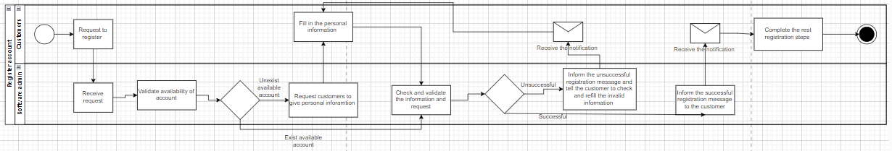

Customers can register an account by clicking on the “Register” button and choosing to fill out a form or use an available account like Google or Facebook. If they choose the form, the admin will ask for personal information and validate the request. If they choose an available account, the admin will immediately validate the request. Successful registrations will receive a confirmation message, while errors will prompt customers to try again.

1. **Get workout information**

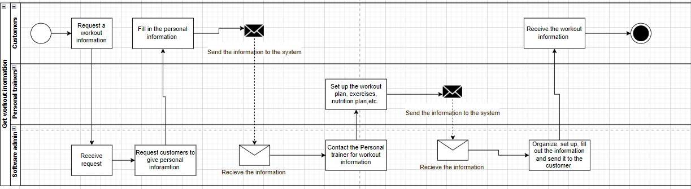

Customers request workout information and provide personal details. The software admin then contacts personal trainers to create a workout plan based on the customer's information. Once the plan is ready, the admin organizes and sends it to the customers, who receive the needed workout information.

**c) Get help and advice**

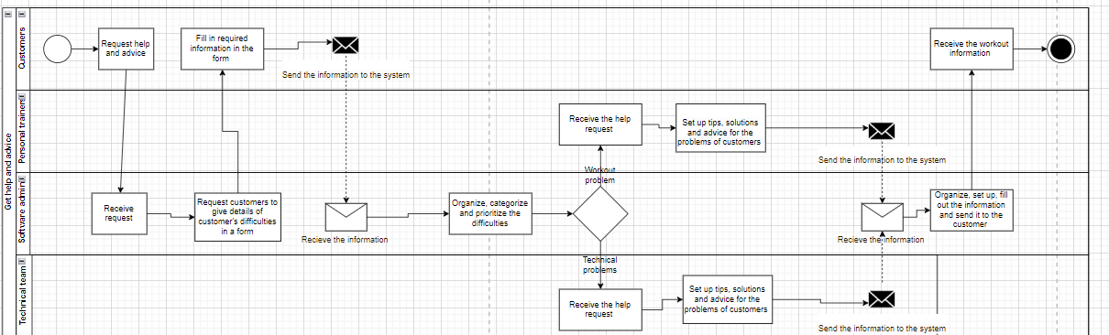

Customers request help and advice by filling out a form. The admin organizes and prioritizes the issues before directing them to the appropriate team for resolution. The PT team handles workout problems, while the Technical team manages technical issues. Both teams provide tips and solutions, which the admin sends to the customers.

**d) Monitoring and tracking the workout process**

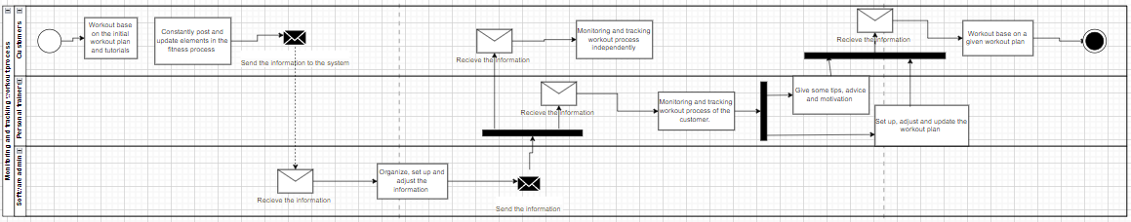

Customers follow the initial workout plan and tutorials, then update their progress in the fitness process. This information is sent to the system, where the admin organizes and adjusts it before sending it to the PT or customers. Customers can independently monitor their workout processes, while the PT provides tips, advice, and updates the workout plan based on the current situation. The customers then follow the given plan.

**2) Usecase**

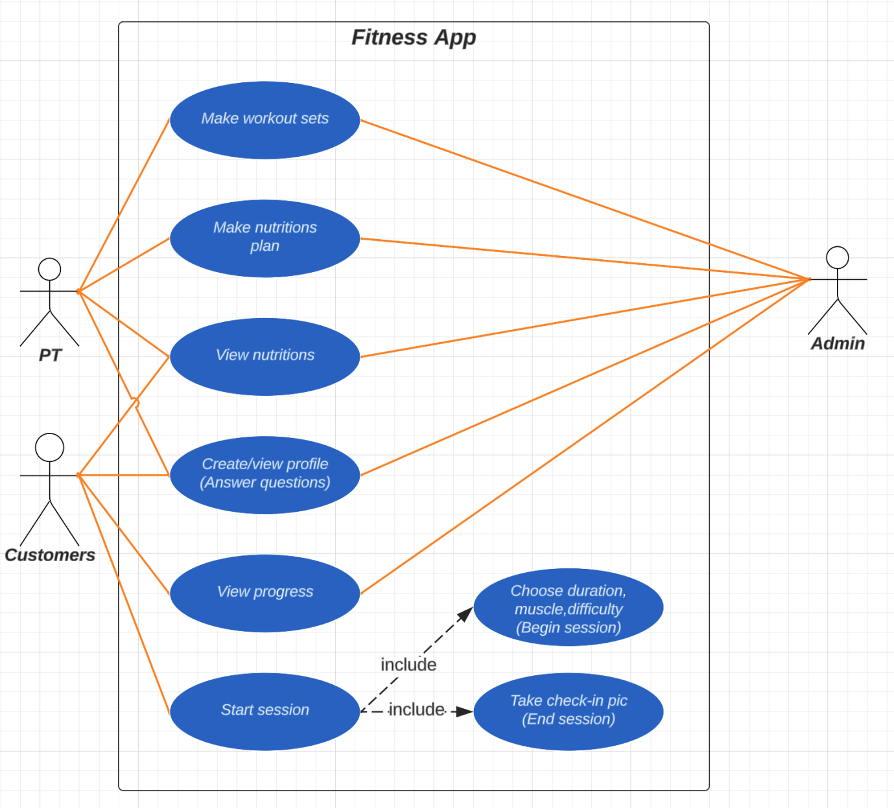

Use Case Diagram

**Details**

**Make workout sets**

Usecase Make-workout-sets:

_Actor: Pt, customer, and Admin

_Pre-Condition:

+PT must have the profile on the apps

_Post-Condition: PT workout sets are in the app systems

_The basic flow of event:

+The PT design customized workout programs on varieties duration, muscle, difficulty

+Admin will upload the workout sets to the database

+After PT receive the latest check-in of the customer after a month, the PT design new customized workout programs based on the latest states

+The process will repeat until the customer end their services

**Make nutrition plan**

Use Case Make-nutrition-plan:

_Actor: Pt and Admin

_Pre-Condition:

+PT must have a profile on the apps

_Post-Condition: PT nutrition is in the app systems

_The basic flow of event:

The PT designs a customized menu that suits the customer needs

Admin will upload the workout sets to the database

After PT receive the latest check-in of the customer after a month in the view nutrition, the PT design new customized menu based on the latest states

The process will repeat until the customer end their services

**View nutrition**

Use Case Nutrition-view:

_Actor: Pt, customer

_Pre-Condition:

+After the customer starts their customized meal in 1 week

_Post-Condition: PT and customer can track the nutrient levels

_The basic flow of event:

+ After a week, the customer will fill in their new health states

+The states will be uploaded to the database and shown into the nutrition tracking page

+The PT will be allowed to see the result from their customer

**Create/view profile**

Usecase create-view-profile:

_Actor: Pt, Customer, Admin

_Pre-Condition:

+PT take the job in the gym

+Customer take the service

_Post-Condition: PT and Customers information are in the app systems

_The basic flow of event:

+At the register menu, there is a question ask that whether they are PT or Customer:

+PT and Customers fill in their personal information

+Admin check the information:

*If the information pass, Admin upload the information to the database

*If the information is false, Admin ask the PT and Customer to refill the incorrect or missing information

+After uploading, admin show the information in the personal information page

**View progress**

Usecase create-view-profile:

_Actor: Pt, Customer

_Pre-Condition:

+After the customer starts their sets in 1 week

_Post-Condition: PT and Customers can track the progress from the customer

_The basic flow of event:

+After a week, the PT will conclude the workout process

+The states will be uploaded to the database and shown into the working tracking page

+The customer will be allowed to see the result from their training

**Start session**

Use Case Start session:

_Actor: Pt, Customer

_Pre-Condition:

+After the customer start their sets in 1 week

_Post-Condition: Customers can take the session that suits for them

_The basic flow of event:

+ Customer start to choose their duration, muscle, and difficulty

+Customer start training based on the session that was given based on their choices

+After finish the session, The customer is asked to take check-in picture to confirm their session

+The check-in picture will be uploaded to the database and sent to the PT

**IV.Wireframe**

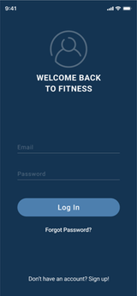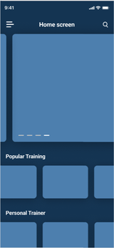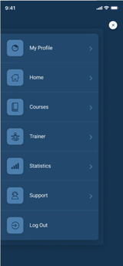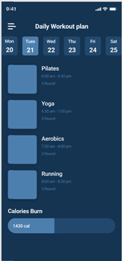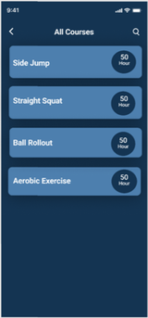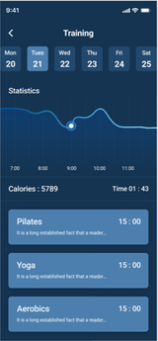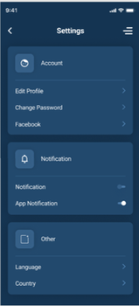

**V. ERD**

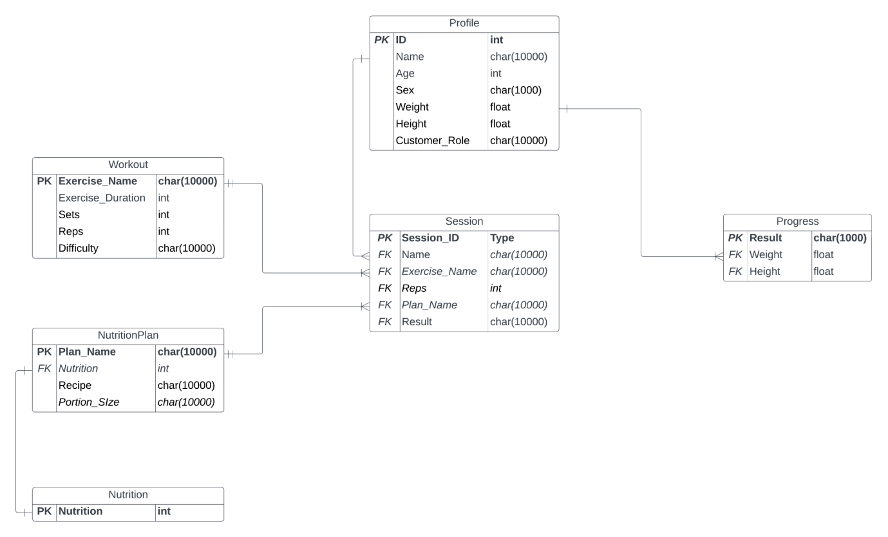

**VI. Activity diagram**

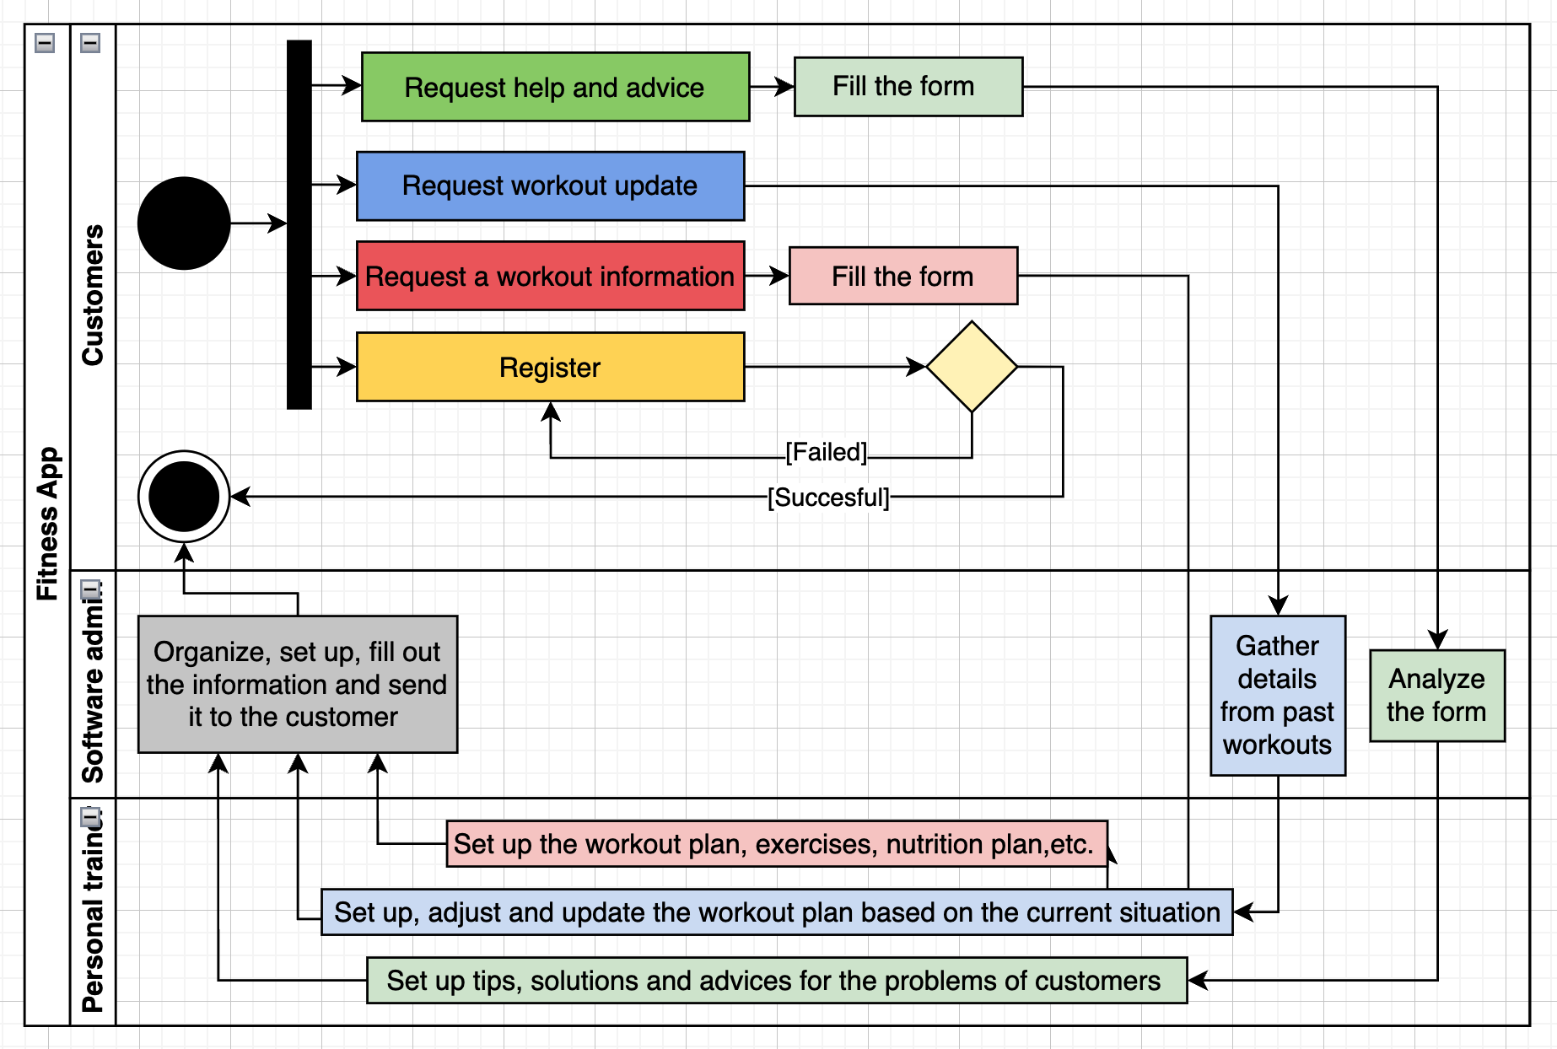

**VII. Class Diagram**

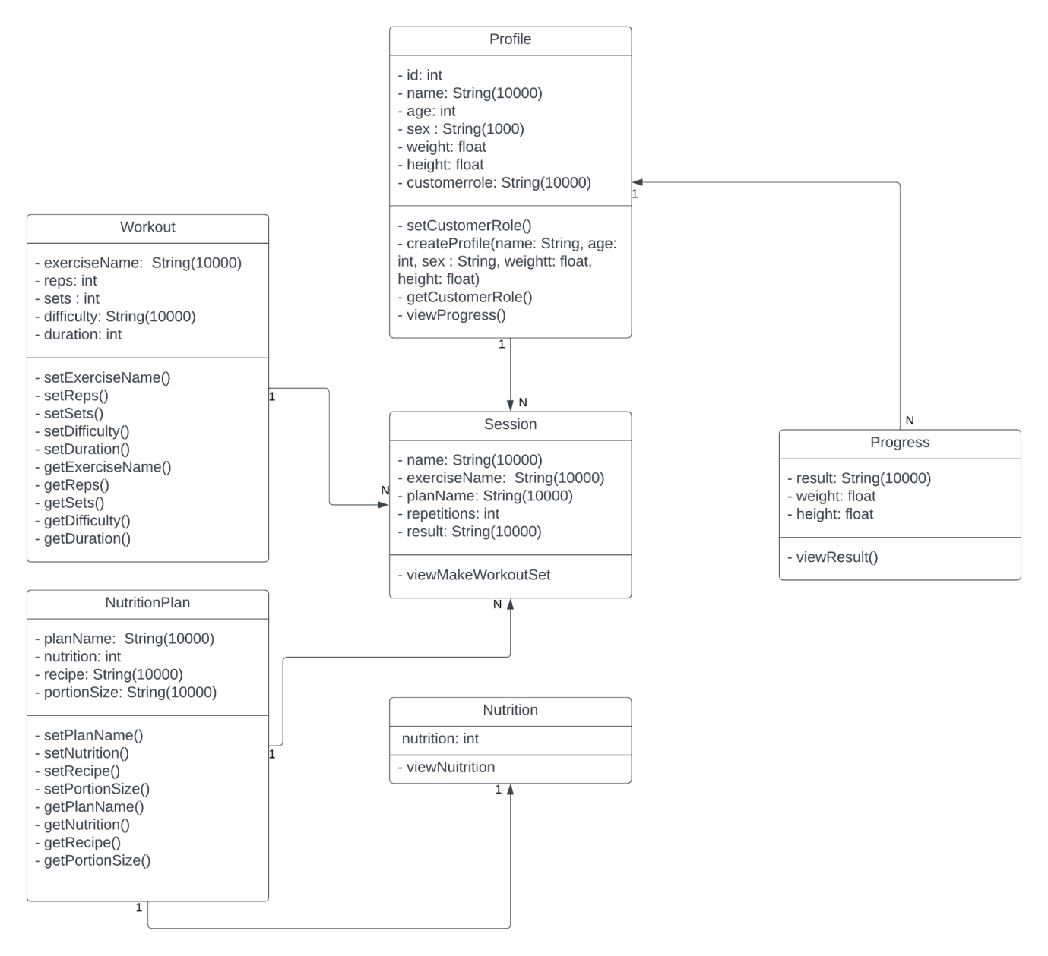

**VIII. Sequence Diagram**

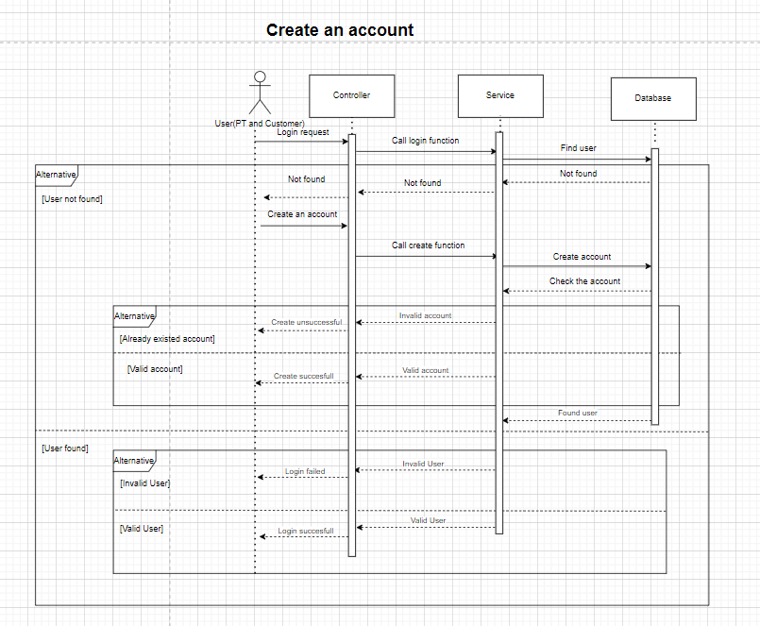

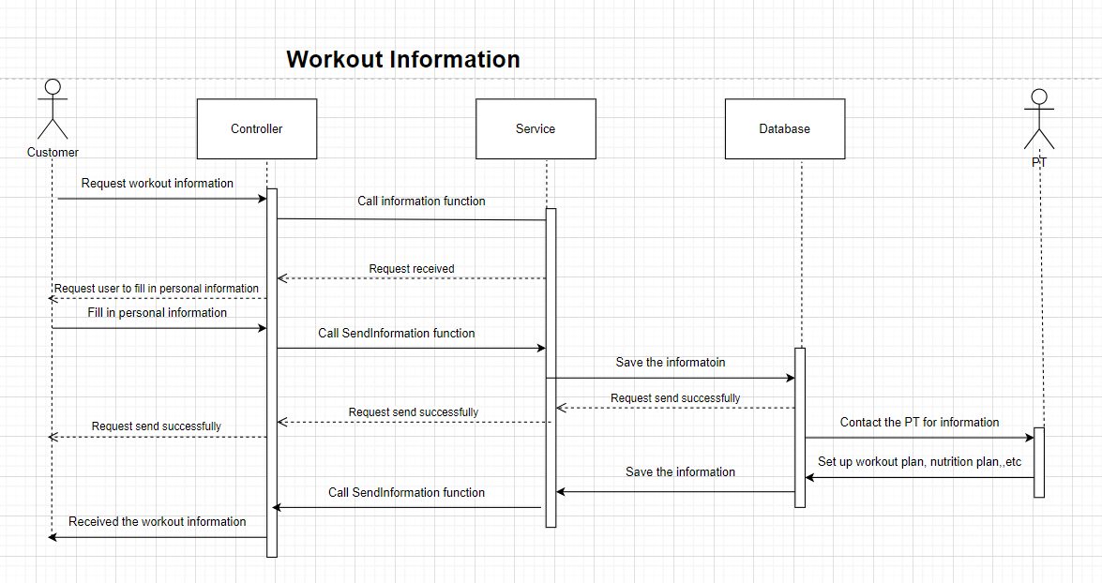

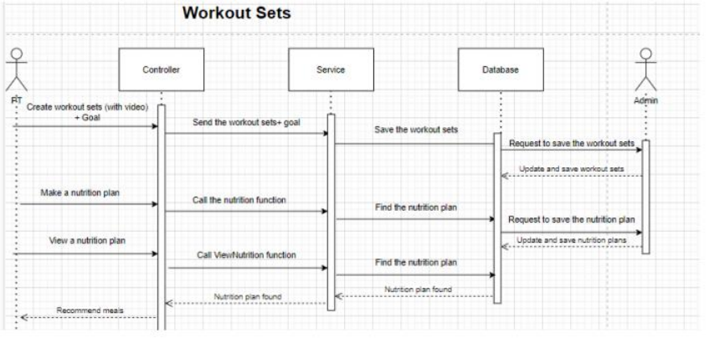

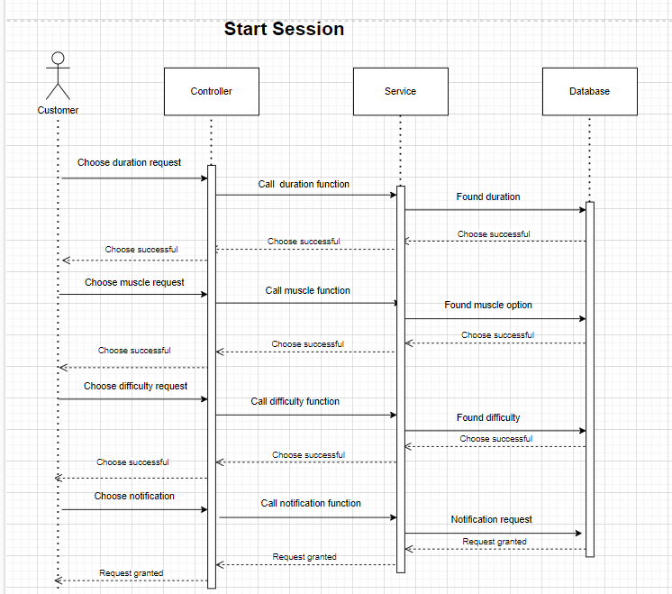

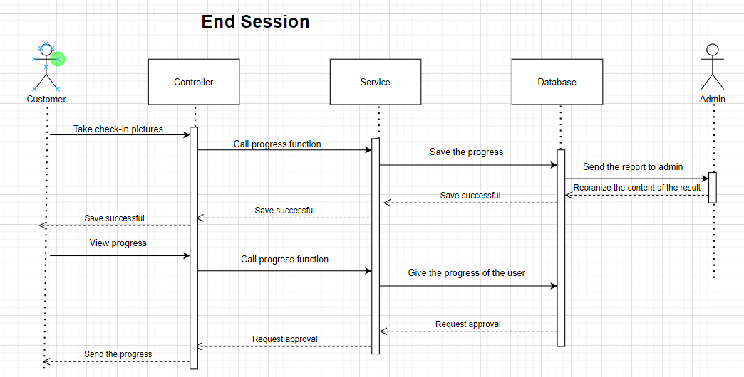

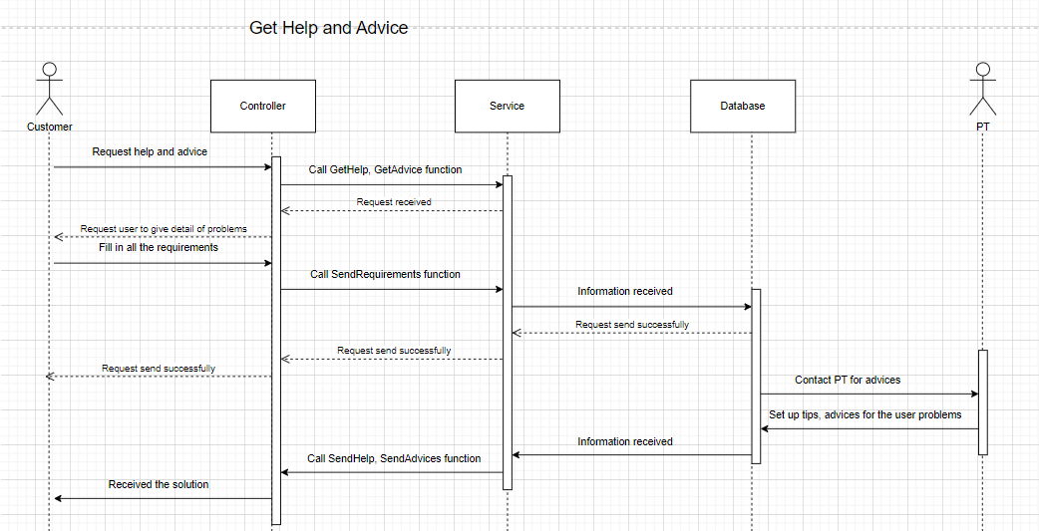

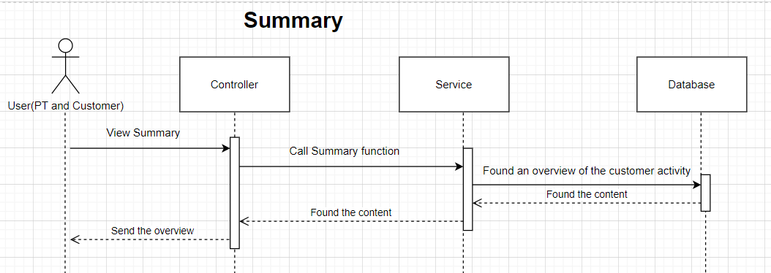

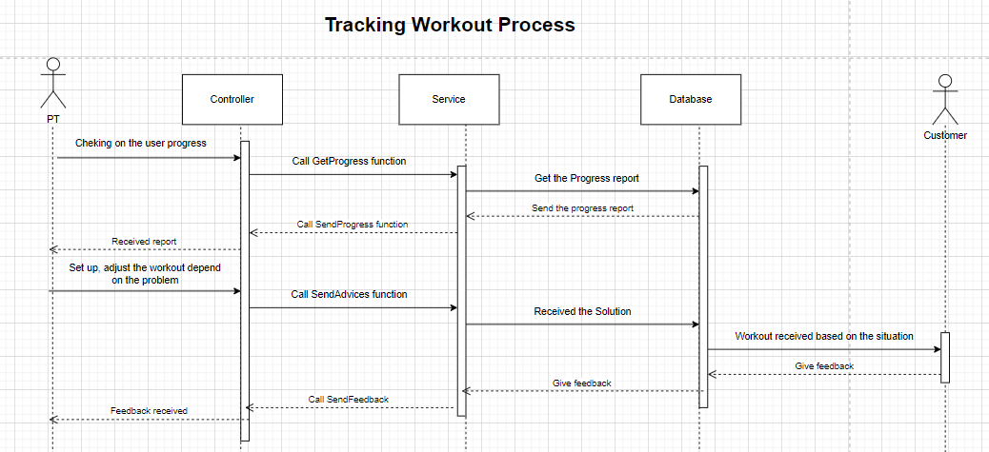

**IX. Requirement Analysis**

**Note:** The table has already been filtered out to each category and in order of priority ( most important at the top to least important at the bottom)

|  |  |  |  |
| --- | --- | --- | --- |
| **Requirement name** | **Description** | **Category** | **Note** |
| Running platform and environment | App is best suit for customer, but web is good for admin to manage | Non- functional |  |
| Required information for tracking and monitoring exercise routine | Day, Time, Food history, Exercise history, Weight,... other metrics about fitness | Non- functional |  |
| Motivation for customer and customer(1) | Products must ensure quality, reasonable prices, and ease of use.  Service: Customer care must be good to encourage customers to return, providing conveniences such as easy online shopping, fast delivery, and quick return policies. | Non - functional |  |
| Motivation for customer and customer(2) | Feedback: Asking for customer reviews and listening to their opinions shows that they are important, leading to a sense of participation and motivation to contribute to the brand's development.  Innovation: Introducing new features, products, or services based on customer feedback and market trends can create customer excitement and motivation.  Promotion program: Discounts for loyal customers. | Non-functional |  |
| Types of private information that the software will store | Personal details, and health information (name, age, address, weight, etc.) | Non-functional | May contain multiple layers of security |
| Number of clicks customers want to make to reach each function interface | Depends on the design (Around 2 - 4 clicks is good number) | Non-functional |  |
| Design | Catchy, friendly, easy-to-use interface | Non-functional | Use color and design that suitable for different of ages |
| Time for system's maintenance | Depends on the complexity of your system. Usually once every 6 months | Non-functional |  |
| Maximum number of customers that the system can contemporarily store | Depends on the size of customer that system can reach | Non-functional | The system now only contains below 100 customers |
| Time the service needs to be available for the customer | 24/7, if all the function can be done automatically without human (in our case is PT and admin) | Non-functional |  |
| Conditions to categorize reviews from customers | Write scenarios (operating scripts), if the customer completes those scenarios without encountering any difficulties, tick completed. If not, see where the customer is having difficulty. Example: The customer wants to update their eating history, they need to enter the date, mealtime, and the food they ate --> the system will save and update if there are any changes, however, the customer can only enter one food, it should be able to enter more --> that scenario is not successful in fulfilling the customer's task. | Functional |  |
| Functions or criteria to build an appropriate set of goals | Goal of the customer: Customers want to track their health, and follow their process flow of daily exercises. | Functional |  |
| Set securities for the private information | Data encryption, secure authentication. Items like password | Functional |  |
| Circumstances to reach help for customers | Text, call or email. Simply put the contact in the website without coding a function just to support | Functional |  |
| Handle with good/ bad comments and feedback from customers | Point out any improvement that the team can do with those feedbacks | Transition | Using Google Form is suggested |
| Sports and fitness rules need to be covered | Need more research | Transition | Currently need to cover Vietnamese rule and regulation only |

**XIX. Risk analysis**

|  |  |  |  |  |  |
| --- | --- | --- | --- | --- | --- |
| **Risk ID** | **Risk Title** | **Affect** | **Probability** | **Impact** | **Risk response plan** |
| 001 | Lack of team corporation | Slow down the progress of the project, unreliable results from the uncooperative work. | Medium | Medium | Solve all the conflicts among team members. |
| 002 | Timeline Tangle | Delays happen to the team members. | Medium | Low | Have self-awareness and time-management efficiently. |
| 003 | More requirements need to be added | Effect on progress of the project. | Medium | Low | Hold a meeting to update the schedule and plan |
| 004 | Over the budget | Project will be shut down if the budget runs out. | High | High | Propose saving plan or financial management. |
| 005 | Scope creep | The slow and sneaky expansion of project goals. Before you know it, you're not building a website; you're building a rocket to Mars. | Medium | High | Set a clear process of things to do |
| 006 | Stakeholder surprises | Might affect the project due to the misunderstandings of what the clients wanted. | Low | High | Have meetings with the clients to discuss clearly about what to achieve. |
| 007 | Privacy and Data security | Fitness tracking and healthcare apps often collect and store sensitive personal health data, such as heart rate, sleep patterns, and exercise routines. The risk of data breaches or unauthorized access to this information is a significant concern. | Medium | Medium | Implement robust security measures, such as encryption, secure data storage, and access controls, to protect customer data. |
| 008 | Inaccurate or Misleading Information | If the app provides health-related advice or recommendations, there is a risk of inaccurate or misleading information being presented. This can lead to potential harm if customers rely on incorrect data for making health decisions. | Low | High | Ensure that the information provided is accurate, up-to-date, and backed by reliable sources. |
| 009 | Reliability and Performance | Users rely on fitness tracking apps for accurate and real-time data. If the app's performance is unreliable or if it frequently crashes or freezes, it can lead to frustration and loss of trust. | Medium | Medium | Test the app for stability, responsiveness, and compatibility across different devices and operating systems. |
| 010 | User Compliance and Behavior | May encourage customers to engage in intense physical activities without considering their individual health conditions or limitations. This can pose a risk of injury or health complications. | Low | Low | Should provide clear disclaimers, warnings, and guidelines to ensure customers understand the limitations and potential risks associated with the app's recommendations. |
| 011 | Integration with Third-Party Devices and Services | Many fitness tracking apps integrate with external devices, such as wearables or smart scales, and may also connect with other health-related services, such as electronic health records or telemedicine platforms. The risk here lies in the security and privacy of data exchanged between the app and these external systems. | Medium | High | Developers should ensure that proper security measures are in place to protect the integrity and confidentiality of data transmitted between different platforms. |
| 012 | User Engagement and Motivation | One of the challenges of fitness tracking apps is maintaining customer engagement and motivation over time. If customers lose interest or fail to find value in the app, it may lead to low adoption rates and limited impact on customers' health behaviors. | Medium | Low | Developers should focus on creating a customer-friendly interface, incorporating gamification elements, and continuously updating the app with new features to keep customers engaged. |

**XI. Progress and challenges**

1. **Timeline**

**a)Team Business**

|  |  |  |
| --- | --- | --- |
| **Job** | **Timeline** | **Responsibility** |
| Obtain knowledge and prepare for writing report | 16/10/2023 - 17/10/2023 | All team members |
| Gather, prioritize and analyze requirements from stakeholders | 18/10/2023 - 20/10/2023 | Đạt, Đức |
| Risk analysis | 18/10/2023 - 20/10/2023 | Huy |
| Draw BPMN | 21/10/2023-25 /10/2023 | Đạt |
| Write Usecase specification and draw Usecase diagram | 18/10/2023 - 22/10/2023 | Hùng |
| Draw Activity diagram | 18/10/2023 - 22/10/2023 | Phúc |
| Draw Class diagram | 23/10/2023 - 25/10/2023 | Hùng |
| Draw Sequence diagram | 26/10/2023 - 27/10/2023 | Huy |
| Complete writing the Midterm report | 28/10/2023 - 30/10/2023 | All team members |
| Adjust and rewrite the Midterm report | 4/12/2023 - 10/12/2023 | All team members |
| Complete the Final report | 11/12/2023 - 15/12/2023 | All team members |

**b) Team Developer**

|  |  |  |  |
| --- | --- | --- | --- |
| **Job** | **Details** | **Timeline** | **Responsibility** |
| Identify functions of app | +Collect customer info  +Activity summaries by specific time +Goal setting +Tracking metrics +Push notification | 16/10/2023 - 17/10/2023 | All team members |
| Planning | + Determine the type of application: Native app  + Research tools and frameworks for recommendations  + Identify specific functions and features  + Determine design requirements  + Design the interface | 18/10/2023 - 20/10/2023 | All team members |
| Developing |  | 20/10/2023 - 28/10/2023 | All team members |
| Testing and evaluation (first time) |  | 28/10/2023 - 30/10/2023 | All team members |
| Complete the report |  | 28/10/2023 - 30/10/2023 | All team members |
| Developing |  | 4/12/2023 - 14/12/2023 | All team members |
| Testing and evaluation (second time) |  | 14/12/2023 - 16/12/2023 | All team members |
| Complete the Final report |  | 14/12/2023 - 16/12/2023 | All team members |

**2) Gantt chart:**

**Team Business:**

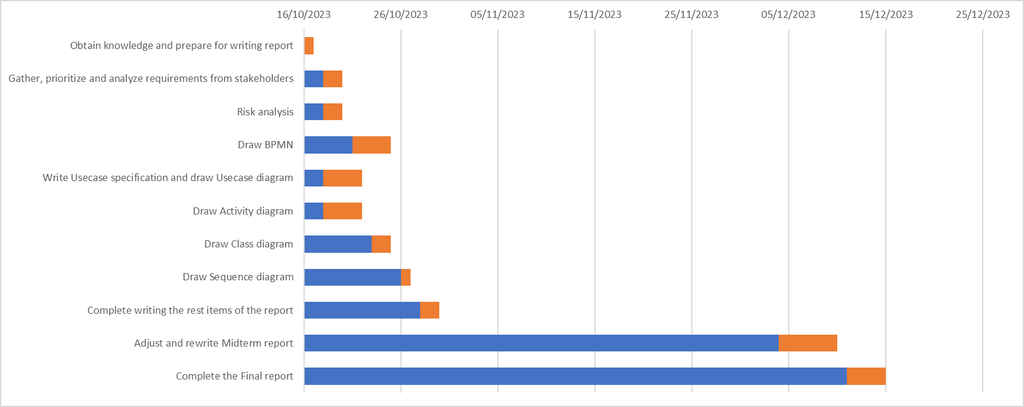

**Team Developer:**

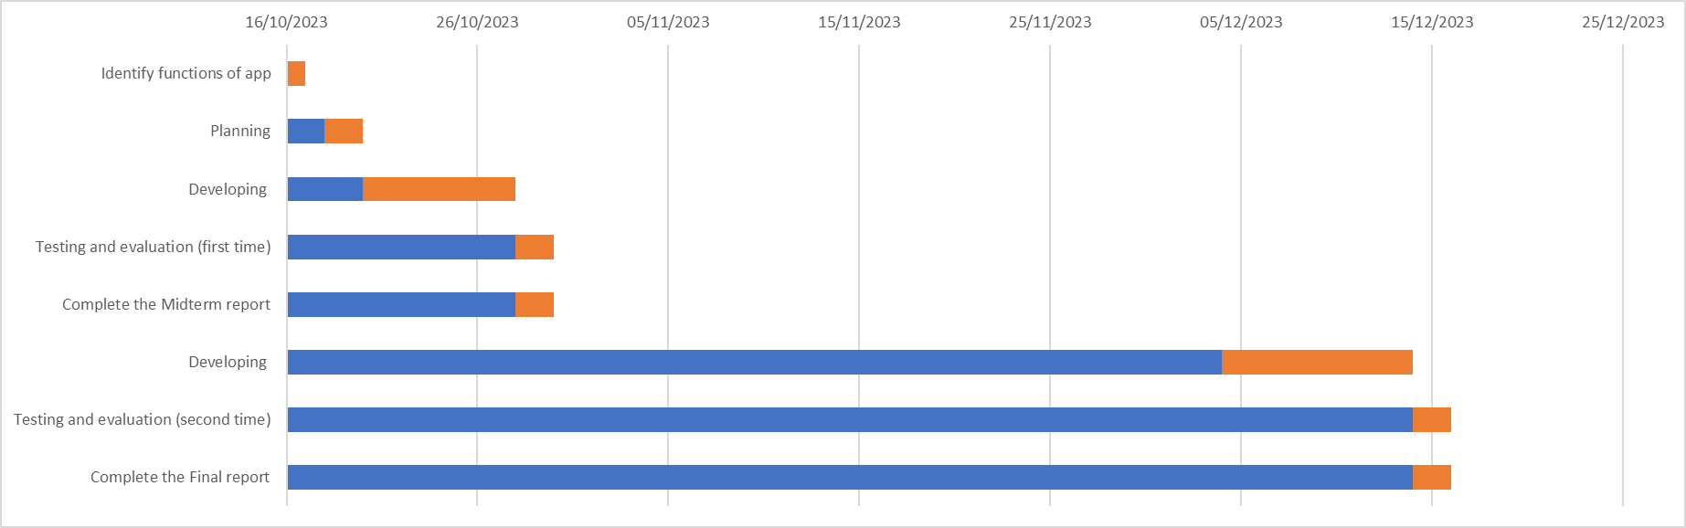

**3) Milestone achieved**

We have achieved some significant milestones in our project. For easier viewing and witness, we break down into 2 categories: business and development

For business criteria:

-We have built a list of questionnaires to gather client requirements. We have used a technique called the BACCM matrix to support this. From that, we have analyzed and prioritized all the requirements.

Moreover, we have successfully drawn and specified all the required UML diagrams and the Use Case specification.

For the development field:

-We have successfully built a model and initial version of our app.

-Next, we all have completed the report of proposal 2 after 3 weeks of working.

- We also successfully built a final and thorough version of our app

- Finally, we have tested the app with our customers as well as the stakeholders. All of their comments, feedbacks and evaluation will be gathered and used for future improvement.

**4) Challenges and obstacles**

**a)Business**

During the project, we encountered significant challenges. A key issue was the lack of expertise in implementing business analysis techniques, methods, and approaches, such as building questionnaires, risk and requirement analysis, and drawing UML diagrams. Misunderstandings between team members also slowed down progress. For example, a team member incorrectly drew a sequence diagram due to a misunderstanding of Use Case specifications. Additionally, meeting deadlines was difficult as team members were often overwhelmed with a high volume of work in a short timeframe.

**b)Development**

* Compatibility with different devices
* Lack of experience in handling emerging errors, knowledge of various frameworks
* Data security design
* Accuracy of tracking data
* Lack of memory, prone to setup errors in coding environment

**5) Solutions**

**a) Business**

We held online meetings to plan and outline our approach for reaching our targets and goals. It was challenging at first, but it provided a clearer path towards achieving our final objective. We spent two days preparing materials and gaining the necessary knowledge and skills, filling a significant expertise gap. Managing and meeting deadlines was crucial, requiring mutual support and motivation. Communication and responsibility were key factors in achieving our goals. The process involved learning, making mistakes, and overcoming them to ultimately succeed.

**b) Development**

Compatibility with different devices -> Solution: Use flexible designs.

* Lack of experience in handling emerging errors, knowledge of various frameworks -> Solution: Utilize knowledge from various online sources such as the Internet and Stack Overflow.
* Data security design -> Solution: Apply security measures such as data encryption.
* Accuracy of tracking data -> Solution: Use available algorithm libraries.
* Lack of memory, prone to setup errors in coding environment -> Solution: Reinstall Windows, and consider utilizing customer-friendly and easy-to-install tools like Flutter Dart.

**XII. Feedback and Future improvement**

**1) Feedback**

The app should use progress tracking to create motivation for users and customers.

**=> This aspect had been applied by the developer team.**

Information such as day, time, food history, exercise history, weight, and other metrics about fitness is needed to keep track of and monitor exercise routine, plans, and nutrition.

**=> Some information was added and the app still updating if there are new requirements from stakeholders**

Using data encryption, secure authentication (password, fingerprint sensor, face id, …) to set securities for private information.

**=> Initially constructed the base and the concept of setting securities.**

Asynchronous processing is recommended to utilize the runtime of the system.

**=> Still not be applied because the app doesn’t finish and test by stakeholder.**

The interface of the function, exercise, diets should be easy-to-use, catchy and friendly in color, design, position of button, components, …

**=> Attractive color, motivated design and many parts of interface decided by developing team had received many good feedback and comm**

**2) Future improvement**

**1. Biometric Integration:**

**Current:** The system tracks basic fitness metrics like steps, calories, and exercise duration.

**Improvement:** Integrate with wearable biometric devices to gather more detailed information, such as heart rate variability, sleep patterns, and stress levels. This could provide a more comprehensive view of an individual's health and wellness.

**2. Virtual Trainer with Form Analysis:**

**Current:** Users follow pre-recorded workout videos.

**Improvement:** Develop a virtual trainer using AI and computer vision to analyze users' exercise forms in real-time. The system could provide instant feedback on form corrections, reducing the risk of injuries and improving the effectiveness of workouts.

**3. Community Engagement:**

**Current:** Limited social features for user interaction.

**Improvement:** Enhance community engagement with features like virtual group workouts, challenges, and forums. This social aspect can provide motivation, support, and a sense of community for users.

**4. Integration with Health Records:**

**Current:** Limited connection with users' overall health history.

**Improvement:** Collaborate with healthcare providers and allow users to integrate their health records. This could enable the system to consider individual health conditions and medical history when generating fitness recommendations.

**5. Gamification for Motivation:**

**Current:** Basic achievement badges for reaching fitness milestones.

**Improvement:** Implement gamification elements, such as interactive challenges, virtual rewards, and competitions. This can make the fitness journey more engaging and enjoyable.

**XII. References and Source Code**

1. [ERD](https://circle.visual-paradigm.com/category/entity-relationship-diagram/?fbclid=IwAR0ueI5ltiy7fdEVGSvsmcaCD4woX-dycjqTEpFA8uq8TZRIb2VOXWqpebc)
2. [Feature for fitness app](https://codetheorem.co/blogs/features-for-fitness-app?fbclid=IwAR2d2U6oTwJTy86O6Hhk8t25XmWf5Fr-6lGZywzMRLv4jokR3WQVoJGsudk#:~:text=A%20fitness%20tracker%20must%20have%20a%20feature%20to%20log%20in,easy%2Dto%2Dfollow%20plans)
3. [Additional features for the fitness app](https://techexactly.com/blogs/top-25-must-have-features-in-your-fitness-gym-app?fbclid=IwAR31iUOfoQOp_3lBH9To-P01p-antdARlUyhSW6EiTxmuOt2MnyosR5ZzhQ)
4. [Drawing UML](https://www.freeprojectz.com/uml-diagram/gym-management-system-uml-diagram)
5. [Source code of our Project](https://l.facebook.com/l.php?u=https%3A%2F%2Fdrive.google.com%2Ffile%2Fd%2F1Et_NOKPyZt_-0Kj8Et2IzH8SmEFSEYG6%2Fview%3Fusp%3Dsharing%26fbclid%3DIwAR3iUmi53vooVwzYLNB74fprALM84DeFp_dmClXtjvfckn3L2aMH6-v-2pk&h=AT3WqZAfbcOeoT0y35Gc2ojINE5Id29oB-SGWMNvedZ5rsxVCK6tACoejiXP1N_mnijrr-yBmqR6XkFzvszTlcS8_DKvfL3k9n5f55cYwru6lv8Cg0SKSXM0RtBZK5hdw4A4Pw) (due to the large size of the file, we have uploaded the zip version on Google Drive)

Github: https://github.com/Vinhss/SE_project?fbclid=IwAR1Wn6CTeEpaI756k52k1I7uShwCxF9K0bWCwNA8O__ITfE_vF31FJhdsQk